**Drug Addiction**

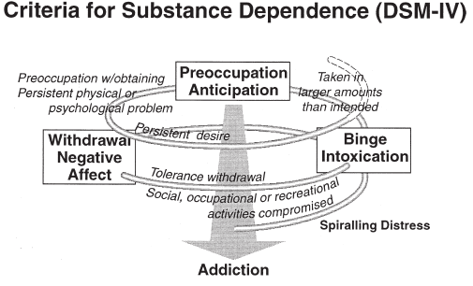 Drug addiction is a recurring relapse disorder that can be characterized by three major characteristics, by (1) compulsion to take the drug, (2) loss of control and thus excessive drug intake, (3) a negative emotional state which is usually caused by withdrawal of the drug (Koob et al.,2010).

Drug addiction is not a static episode and can be very well represented by an increasing addiction cycle (Baumeister et al. 1994). The psychiatric addiction cycle consists of three major factors: Binge-intoxication, withdrawal-negative effects and preoccupation/anticipation (Koob and Le Moal, 1997). Spiraling distress acts as the reason to why an early self-regulation failure can be the cause of emotional distress and therefore be the reason to set the cycle in motion. Spiraling distress can also be defined as the gradual disruption of the dopamine reward system within the context of reoccurring addiction cycles.

It is also important to mention that the addiction cycle contains the idea of a constant play of positive and negative reinforcements. In which positive reinforcement can often be described as the satisfying effects, induced by drug use, in the absence of any negative emotions. Whereas negative reinforcement is associated with an alleviation of a negative state for example caused by drug withdrawal (Wikler, 1973). Positive reinforcement relates mostly to the binge intoxication state in the addiction cycle and negative reinforcement is related to the withdrawal negative-affect state. Conditioned positive and negative reinforcement occurs by pairing a neutral cue with an acute positive effect of a drug, whereas those are related to the preoccupation/anticipation stage. The three stages of the addiction cycle therefore interact with each other and become worse the longer this cycle goes on, which in the end leads to what one understands as drug addiction (Koob and Le Moal, 1997).

The shift from recreational drug use to addiction is based on the change of several neurocircuitry pathways, one of the most important ones being the mesolimbic dopamine pathway, which will be discussed in more detail later in this review.

**Figure 4 |** This figure depicts the idea of a spiraling addiction cycle. Containing the three major components: Binge intoxication, withdrawal negative-effect and preoccupation anticipation. The basic idea of this diagram is to show that each cycle in this spiral will add up and ultimately lead to addiction (Diagnostic and Statistical Manual of Mental Disorders, 4th edition).

**Classification of Drugs**

Most known drugs of abuse, for example alcohol, cocaine, marijuana etc. act on elements which are part of the limbic circuitry and thus lead to upregulation of dopaminergic projections from the ventral tegmental area into the nucleus accumbens (Purves et al, 6th edition).

These drugs can be categorized into three different groups (Figure 5), depending on how they achieve increased dopamine projection (Nugent et al, 2007). Class 1 contains drugs such as opioids or ∆-9-Tetrahydrocannabinol (THC). These usually bind to G protein-coupled receptors and act as an agonist on these receptors which are found in GABA inhibitory interneurons. Binding to the GPCRs leads to disinhibition of dopaminergic neurons in the ventral tegmental area (Lüscher and Ungless, 2006). Drugs like nicotine or ethanol, that are consumed by a large part of todays society, belong to the second class. These drugs act on the channels located on

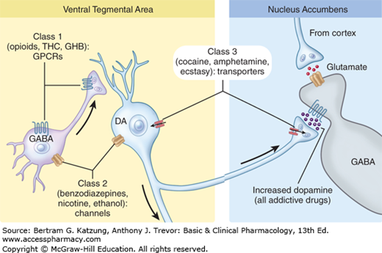GABA inhibitory interneurons or dopaminergic neurons in the ventral tegmental area. Class three drugs on the other hand can act in both the ventral tegmental area and the nucleus accumbens. These drugs inhibit the reuptake of neurotransmitters such as dopamine, e.g. cocaine or ectasy inhibit the monoamine transporters which are responsible for reuptake of dopamine and therefore lead to a stronger dopaminergic signal in the nucleus accumbens (Katzung et al, 13th edition).

As one can see, all the prominent abusive drugs lead to a higher dopaminergic signal in the nucleus accumbens in one way or another and thus directly trigger the dopamine reward system. This effect seems to play a fundamental role in the process which leads to drug addiction, because of the earlier mentioned neuroplasticity changes which are caused by disruption of the reward system.

**DA signaling**

The ventral striatal direct and indirect pathways both play an important role in DA signaling induced by drug reward. Previous studies showed an association of the direct pathway with reward. On the contrary the indirect pathway is associated with punishment (Hikida et al., 2010; Kravitz et al., 2012). Therefore, increased binding of DA to D1R leads to a reward response, whereas binding to D2R mediates aversive responses of the reward system.

**Figure 5 |** Shows a DA neuron in the VTA that projects into the NAc, DA neuron is shown to be inhibited by GABA neuron. Three classes of abusive drugs are shown that all lead to increased DA in the NAc. Class one and two only act in the VTA whereas class three drugs act in VTA and NAc.

Experiments showed that activation of the indirect pathway is mandatory to produce drug reward, contrary to the activation of the indirect pathway on its own which does not lead to any drug reward (Caine et al., 2007; Caine et al. 2002; Durieux et al., 2009; Norman et al., 2011). Activation of both pathways leads to the biggest drug reward (Steinberg et al., 2014; Welter et al., 2007). Additionally, D2R show low affinity towards DA compared to D1R. This further means that DA increases need to be fast and specifically large enough to activate D1R receptors, so that the direct pathway will be activated and the indirect pathway will be inhibited. Further experiments confirmed that drugs which cause fast increases in DA lead to an increased drug “high” in comparison with drugs that lead to a slower and smaller DA increase (Volkow et al., 2008). More precisely, large DA increases by drugs over a short amount of time (< 10 min) were associated with the drug “high” whereas DA increases over a larger amount of time (> 60 min) showed barely an effect in terms of drug “high” and therefore suggesting no specific drug reward (Figure 6). All those observations lead us to the conclusion that a fast and big enough DA increase is necessary to activate both pathways and achieve the best drug reward signaling. Moreover, it may also explain why the way of consummation might be of great importance in regard of addiction, because faster routes of administration like intravenous injections lead to a bigger and faster DA peak, compared to slow routes of administration such 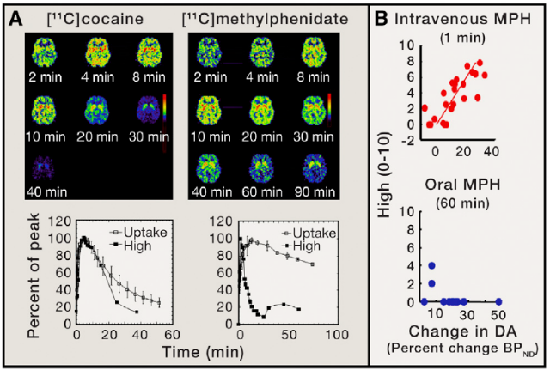as oral consumption (Volkow et al., 2015).

**Figure 6 |** (A) Shows pharmacokinetics of cocaine and methylphenidate. On the top, axial brain images after intravenous drug uptake at different times are shown. On the bottom, time activity curves of both drugs are depicted in combination with drug “high”. This figure suggests that the “high” is directly associated with the rate of DA increases.

(B) Linear regression between drug “high” and methylphenidate induced DA increase is plotted, comparing intravenous vs. oral route of administration. Clearly shows that oral way of consumption barely leads to a “high”, because of the slow brain uptake. (Volkow et al., 2015)

**Reward prediction error and addiction**

Since reward prediction error (RPE) has already been discussed in this review in a more general matter, we will now focus on how it is related to addiction and may be fundamental to cause addiction or lead to relapse. To shortly summarize prior knowledge about RPE, it can be described as the difference between what was predicted and what was received. The RPE is said to be positive if what was received is bigger than what was predicted and the RPE is negative if what was predicted was bigger than what was received (Purves et al., 6th edition).

Drug consumption that leads to big enough DA increases, as discussed in the previous part, are sufficient to activate D1R which can then lead to associative learning also known as conditioning which is crucial for RPE (Zweifel et al., 2009). Cues that are associated with drug consumption can become conditioned after a certain amount of training time, after sufficient training time those cues that are associated with drug consumption can then trigger DA neuronal firing in the VTA which then leads to big enough DA increases in the NAc. The RPE theory basically states that those DA increases coupled to associated cues mirror the expectation of receiving a reward.

If we now look at a natural reinforcer such as food, the RPE will be balanced out after extended training, which means that the DA cells will stop firing after food consumption (Schultz et al., 1997). On the contrary there will be a positive RPE after drug consumption, due to the chemical properties of abusive drugs which promote DA increase in the NAc. This now positive RPE leads to what is known as craving, more precisely the desire to take the drug also during its consumption and therefore leading to an ongoing motivation to keep consuming the drug (Volkow et al., 2015). In other words, drug consumption leads to a linear increasingly cue value because of the positive RPE which is caused by the pharmacological properties of abusive drugs.

**Drug induced Neuroplasticity**

Strengthening or weakening of synaptic connectivity was confirmed to be caused by large enough drug-induced DA increases (Grueter et al., 2012). It is being hypothesized that such neuroplastic changes are based on several changes in epigenetic enhancing/silencing of gene expression and on epitranscriptomic modulation of translation (Kenny, 2014; Robison et al., 2011, Satterlee et al., 2014). Drug induced neuroplasticity induces the same mechanisms that are responsible for learning and memory. Long term potentiation (LTP) is associated with larger synapses and dendritic spines, whereas long term depression (LTD) is linked to smaller synapses and dendritic spines (De Roo et al., 2008). These mechanisms are therefore responsible for creating a long-lasting molec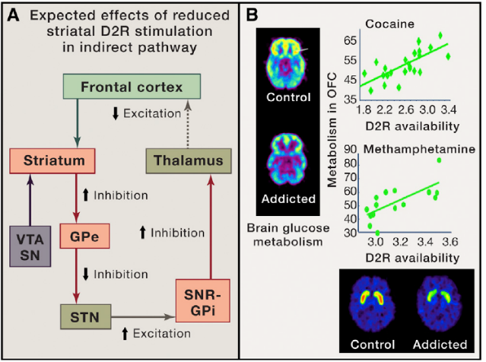ular memory for drug rewarding and conditioning effects (Hyman et al. ,2005). Synaptic strength can be regulated through addition or removal of AMPAR or NMDAR, as well as changes in the subunit compositions of AMPAR. Alteration of AMPAR further leads to increased responsiveness of medium spiny neurons to glutamate in the NAc. To summarize, the increased AMPAR/NMDAR ratio in the VTA leads to further neuroplasticity changes, after repeated exposure, and may in the end lead to behavioral consequences such as relapse to drug seeking (Volkow et al., 2015).

**D2R and addiction**

Several studies have described a downregulated expression of D2R in the striatum after chronic drug administration. Low expression of D2R in the striatum of rodents are also related to escalating and compulsive administration of cocaine (Everitt et al., 2008). Similar results were found in human brain imaging studies for most of the drugs, except marijuana (Volkow and Baler, 2014). As previously mentioned D2R binding is responsible for inhibition of the indirect pathway. Reduced expression of D2R will then end up in reduced inhibition of the indirect pathway. This will lead to reduced excitation of prefrontal cortex (PFC) areas (Figure 7) (Black et al., 2010). Of major importance are the anterior cingulate cortex (ACC) and orbitofrontal cortex (OFC) which are located in the PFC. Those two areas are necessary for self-control and for processing salience attribution, their disruption has been associated with a tendency for impulsive and compulsive behaviors (Volkow and Fowler, 2000). Therefore, reduced D2R expression might enhance the risk for compulsive drug seeking behavior and thus resemble an important cause that leads to drug addiction. Studies in rodents showed results in favor of this hypothesis, in which optogenetic stimulation of the PFC prevented cocaine relapse (Chen et al., 2013).

**Figure 7 |** (A) Schematic overview of the indirect DA pathway. DA neurons from ventral tegmental area (VTA) and substantia nigra compacta (SNc) project DA signaling into striatal GABA neurons expressing D2R. These striatal neurons then target GABA cells in the globus pallidum external (GPe), which inhibits glutamatergic neurons in the subthalamic nucleus (STN). STN glutamatergic neurons further excite GABA neurons in the substantia nigra reticulata (SNr) and the globus pallidum internal (GPi), those two structures inhibit glutamate neurons in the thalamus which innervates the frontal cortex. Reduced expression of D2R in the striatum therefore leads to impairment of the indirect pathway, resulting in the reduced excitation of the frontal cortex

(B) Shows brain glucose metabolism of control and addicted individual, both tested with [11C]racloperide and FDG. On the right side correlation between D2R availability and metabolism in the OFC region is depicted, once with cocaine on the top and below with methylamphetamine. Positive slopes show us the correlation of D2R availability and OFC brain metabolism.

(Volkow et al., 2015)

**Dopamine and food addiction**

Since obesity has become a very important topic in recent years, several studies tried to explain how an individual develops food addiction and in what way it might be connected with the reward system, especially the neurotransmitter DA. Recent studies suggest strong evidence that similar to drug addiction, food addiction involves the dopaminergic reward circuitry of the brain. We will in this review shortly present the concept of food addiction and results of recent experiments.

**Dopamine signaling in food reward**

As we previously discussed in this review, drugs of abuse such as cocaine can alter the dopaminergic mesolimbic system. Several experiments have also shown that palatable food can activate this DA reward circuitry, therefore we can conclude that food addiction has to act in a similar way to drug addiction, in a way that both depend on dopaminergic circuits. Additionally, brain imaging studies have shown that dopaminergic circuits most certainly play a role in the control of food intake (Wang et al., 2001; Small et al., 2001; Volkow et al., 2011).

Comparable to drugs of abuse, studies have shown that rewarding of food stimulates dopaminergic transmission from the VTA into the NAc. Roitman and colleagues have also shown that a cue associated with food reward lead to a DA increase in the NAc (Roitman et al., 2004). Therefore, indicating that DA signaling in the NAc acts as a real-time modulator of food-seeking behavior. However, various other studies have shown that the dorsal striatum is of major importance in regard of food addiction. Especially in humans the dorsal striatum was found to possess a correlation with feeding behaviors. Small and colleagues used positron emission tomography (PET) to reveal that feeding-induced dopamine release in dorsal striatum correlates with meal pleasantness ratings in humans rather than NAc (Small et al., 2003). Additional to these findings, reduced striatal D2R expression has been found in obese individuals in proportion to their body mass index, similar to the scenario that occurred in drug addicted individuals (Wang et al., 2001). This might suggest that DA deficiency may lead to overeating in such a way that eating too much food may compensate for decreased activation of dopaminergic reward circuits. Another possible explanation could be that reduced D2R expression may lead to changes in behavior that lead to addiction, in a similar way to what we already discussed in addiction caused by abusive drugs. Volkow and coworkers revealed a significant association between D2R expression levels and cingulate gyrus (CG), dorsolateral prefrontal cortex (DLPFC) and orbitofrontal cortex. Those areas are involved in inhibitory control, salience attribution and emotional reactivity, which means that disruption of those regions can lead to impulsive and compulsive behaviors (Volkow et al., 2008).

**Conclusion**

During the last decades, various studies have been done to figure out the causes of addiction and the mechanisms behind it. Dopamine circuits were found to be of major importance and promising hypotheses were proposed. One of the most prominent one being the reward prediction thesis, which also very well explains how the reward system might lead to addiction after chronic drug reward. In addition, several studies have indicated a connection between D2R and neurocircuitry changes. This seems to be a promising approach for further studies, because there are still some controversies that need to be solved. All in all one can say that better understanding of the dopamine reward system might be very useful to further the understanding of drug addiction.

Experiments have shown the importance of the DA system in terms of controlling eating behavior, especially the D2R is of great importance in food reward. Furthermore, several similarities between addictive drug behavior and food addiction have been observed. Those findings provide a solid foundation for further research that will have to be carried out in direction of food addiction.

George F Koob and Nora D Volkow (2010). Neurocircuitry of Addiction. Neuropsychopharmacology Reviews (2010) 35, 217–238.

Koob GF, Le Moal M (1997): Drug abuse: Hedonic homeostatic dysregulation. Science 278:52–58

Wikler A (1973): Dynamics of drug dependence: Implications of a conditioning theory for research and treatment. Arch Gen Psychiatry 28:611–616

American Psychiatric Association (1994): Diagnostic and Statistical Manual of Mental Disorders, 4th ed. Washington DC, American Psychiatric Press

Purves et al. (2018) sith edition. Published in the United States of America by Oxford University Press 198 Madison Avenue, New York, NY 10016, United States of America

Lüscher, Christian; Ungless, Mark A. (2006): The mechanistic classification of addictive drugs. In PLoS medicine 3 (11), e437. DOI: 10.1371/journal.pmed.0030437

Anthony J. Trevor, Bertram G. Katzung (2015). Basic and Clinical Pharmacology 13th edition

Hikida, T., Kimura, K., Wada, N., Funabiki, K., and Nakanishi, S. (2010). Distinct roles of synaptic transmission in direct and indirect striatal pathways to reward and aversive behavior. Neuron 66, 896–907.

Kravitz, A.V., Tye, L.D., and Kreitzer, A.C. (2012). Distinct roles for direct and indirect pathway striatal neurons in reinforcement. Nat. Neurosci. 15, 816–818.

Caine, S.B., Thomsen, M., Gabriel, K.I., Berkowitz, J.S., Gold, L.H., Koob, G.F., Tonegawa, S., Zhang, J., and Xu, M. (2007). Lack of self-administration of cocaine in dopamine D1 receptor knock-out mice. J. Neurosci. 27, 13140–13150.

Caine, S.B., Negus, S.S., Mello, N.K., Patel, S., Bristow, L., Kulagowski, J., Vallone,

D., Saiardi, A., and Borrelli, E. (2002). Role of dopamine D2-like receptors in cocaine self-administration: studies with D2 receptor mutant mice and novel D2 receptor antagonists. J. Neurosci. 22, 2977–2988.

Durieux, P.F., Bearzatto, B., Guiducci, S., Buch, T., Waisman, A., Zoli, M., Schiffmann, S.N., and de Kerchove d’Exaerde, A. (2009). D2R striatopallidal neurons inhibit both locomotor and drug reward processes. Nat. Neurosci. 12, 393–395.

Norman, A.B., Tabet, M.R., Norman, M.K., Fey, B.K., Tsibulsky, V.L., and Millard, R.W. (2011). The affinity of D2-like dopamine receptor antagonists determines the time to maximal effect on cocaine self-administration. J. Pharmacol. Exp. Ther. 338, 724–728.

Steinberg, E.E., Boivin, J.R., Saunders, B.T., Witten, I.B., Deisseroth, K., and Janak, P.H. (2014). Positive reinforcement mediated by midbrain dopamine neurons requires D1 and D2 receptor activation in the nucleus accumbens. PLoS ONE 9, e94771.

Welter, M., Vallone, D., Samad, T.A., Meziane, H., Usiello, A., and Borrelli, E. (2007). Absence of dopamine D2 receptors unmasks an inhibitory control over the brain circuitries activated by cocaine. Proc. Natl. Acad. Sci. USA 104, 6840–6845.

Volkow, N.D., Wang, G.J., Telang, F., Fowler, J.S., Logan, J., Childress, A.R., Jayne, M., Ma, Y., and Wong, C. (2008). Dopamine increases in striatum do not elicit craving in cocaine abusers unless they are coupled with cocaine cues. Neuroimage 39, 1266–1273.

Volkow ND, Morales M (2015). The Brain on Drugs: From Reward to Addiction. Cell 2015 Aug 13;162(4):712-25

Zweifel, L.S., Parker, J.G., Lobb, C.J., Rainwater, A., Wall, V.Z., Fadok, J.P., Darvas, M., Kim, M.J., Mizumori, S.J., Paladini, C.A., et al. (2009). Disruption of NMDAR-dependent burst firing by dopamine neurons provides selective assessment of phasic dopamine-dependent behavior. Proc. Natl. Acad. Sci. USA 106, 7281–7288.

Schultz, W., Dayan, P., and Montague, P.R. (1997). A neural substrate of prediction and reward. Science 275, 1593–1599.

Grueter, B.A., Rothwell, P.E., and Malenka, R.C. (2012). Integrating synaptic plasticity and striatal circuit function in addiction. Curr. Opin. Neurobiol. 22, 545–551.

Kenny, P.J. (2014). Epigenetics, microRNA, and addiction. Dialogues Clin. Neurosci. 16, 335–344.

Robison, A.J., and Nestler, E.J. (2011). Transcriptional and epigenetic mechanisms of addiction. Nat. Rev. Neurosci. 12, 623–637.

Satterlee, J.S., Basanta-Sanchez, M., Blanco, S., Li, J.B., Meyer, K., Pollock, J., Sadri-Vakili, G., and Rybak-Wolf, A. (2014). Novel RNA modifications in the nervous system: form and function. J. Neurosci. 34, 15170–15177.

De Roo, M., Klauser, P., Garcia, P.M., Poglia, L., and Muller, D. (2008). Spine dynamics and synapse remodeling during LTP and memory processes. Prog. Brain Res. 169, 199–207.

Hyman, S.E. (2005). Addiction: a disease of learning and memory. Am. J. Psychiatry 162, 1414–1422.

Everitt, B.J., Belin, D., Economidou, D., Pelloux, Y., Dalley, J.W., and Robbins, T.W. (2008). Review. Neural mechanisms underlying the vulnerability to develop compulsive drug-seeking habits and addiction. Philos. Trans. R. Soc. Lond. B Biol. Sci. 363, 3125–3135.

Volkow, N.D., and Baler, R.D. (2014). Addiction science: Uncovering neurobiological

complexity. Neuropharmacology 76 Pt B, 235–249.

Volkow, N.D., and Fowler, J.S. (2000). Addiction, a disease of compulsion and drive: involvement of the orbitofrontal cortex. Cereb. Cortex 10, 318–325.

Wang, G. J., Volkow, N. D., Logan, J., Pappas, N. R., Wong, C. T., Zhu, W., Netusil, N. and Fowler, J. S. (2001) Brain dopamine and obesity. Lancet. 357, 354-357.

Small, D. M., Zatorre, R. J., Dagher, A., Evans, A. C. and Jones-Gotman, M. (2001) Changes in brain activity related to eating chocolate: from pleasure to aversion. Brain 124, 1720-1733.

Volkow, N. D., Wang, G. J. and Baler, R. D. (2011) Reward, dopamine and the control of food intake: Implications for obesity. Trends Cogn. Sci. 15, 37-46.

Roitman, M. F., Stuber, G. D., Phillips, P. E., Wightman, R. M. and Carelli, R. M. (2004) Dopamine operates as a subsecond modulator of food seeking. J. Neurosci. 24,

1265-1271.

Small, D. M., Jones-Gotman, M. and Dagher, A. (2003) Feeding-induced dopamine release in dorsal striatum correlates

with meal pleasantness ratings in healthy human volunteers. Neuroimage 19, 1709-1715.

Volkow, N. D., Wang, G. J., Telang, F., Fowler, J. S., Thanos, P. K., Logan, J., Alexoff, D., Ding, Y. S., Wong, C., Ma, Y. and Pradhan, K. (2008) Low dopamine striatal D2 receptors are associated with prefrontal metabolism in obese subjects: possible contributing factors. Neuroimage

42, 1537-1543.